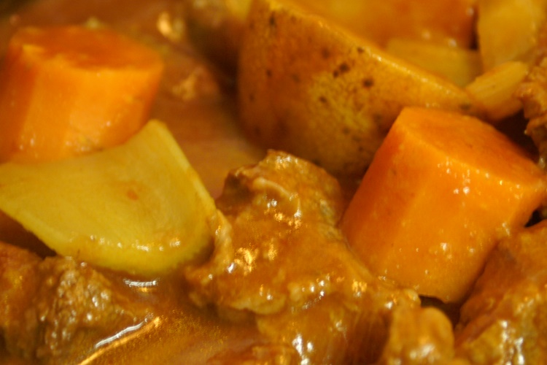
Lob Sgows
- Beef
- Potatoes
- Onions
- Carrots
- Lentils
- Beef or vegetable stock
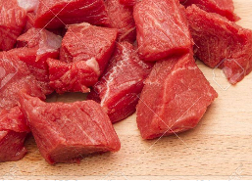
- Salt
Method
- Cut beef into small pieces
- Put in air fryer to brown.
- Cut potatoes into chunks and chop carrots.
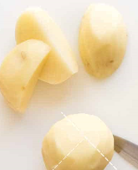
- Place into slow cooker.
- Break a cube a cube of stock into pot
- Add beef cover it with water
- Cook on low for 6 hours

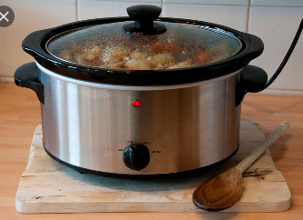
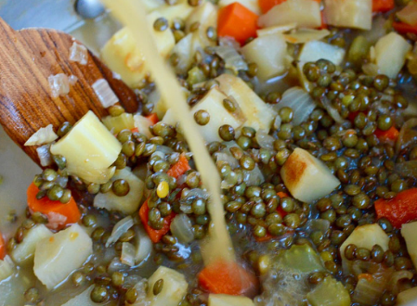
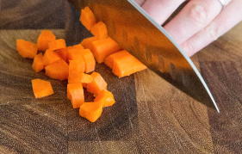
Serve with crusty bread…..

