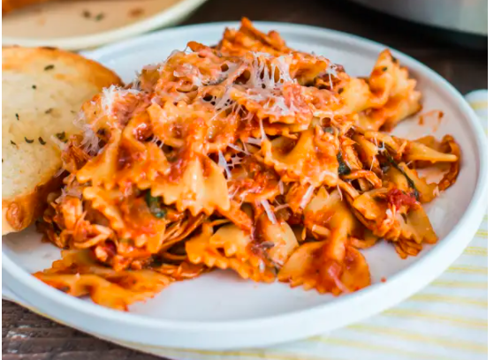
Chicken and Bacon slow cooker Pasta

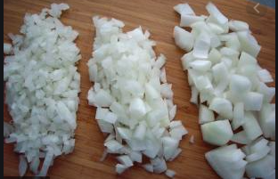
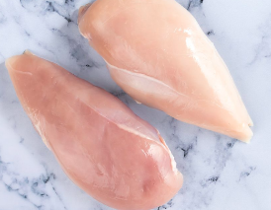
Ingredients:

Chicken breast

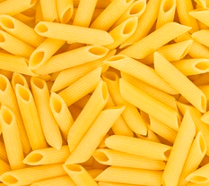
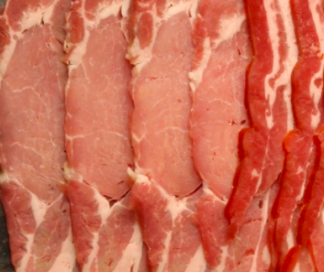
Diced onion

Cut bacon (cooked)

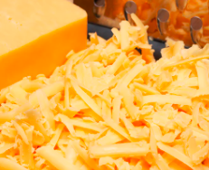
Pasta sauce

Pasta

Cheese

Method.
Place onions, chicken and sauce into slow cooker. Cook on medium for 3 hours and add pasta for the last half hour. Add the bacon when adding the pasta. Make sure the bacon is cooked. :
You can cook Bacon In the microwave for 1 minute per rasher. (2 rashers-2 minutes) place bacon on some kitchen roll and on to a microwaveable plate. Replace kitchen roll half way through..
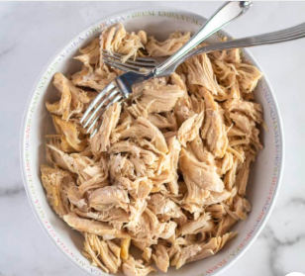
When it’s ready you can “shred” the chicken and sprinkle the dish with cheese to your liking.

